Global Campaign for Inclusion

Request for Proposal

Global Thought Leader Campaign

Issue Date: 5 November 2021

Response Due Date: 17 December 2021 11:59 PM ET

# Table of Contents

Statement of Purpose……………………………..……………………………………3

Background Information…………………………………………………………….….3

Summary of Project……………………………………………………………………..5

Proposal Guidelines…………………………………………………………………..…6

Project Scope…………………………………………………………………………….7

Purpose…………………………………………………………………………………...8

Supporting Staff…………………………………………………………………………9

RFP and Project Timelines……………………………………………………………...9

Proposal Requirements…………………………….…………………………………10

Budget………………………………………………………………………………..…10

Proposal Evaluation Criteria………………………………………………………….10

Point of Contact………………………………………………………………………..11

Appendix 1……………………………………………………………………………...12

Appendix 2……………………………………………………………………………...26

# STATEMENT OF PURPOSE

Through this Request for Proposal (RFP), Special Olympics will identify a public relations expert that will aid in the development of their Global Thought Leader Campaign to target cultural, political, and academic thought leaders with Special Olympics’ message of inclusion. The entity will aid in securing placements at key convenings for campaign spokespeople, as well as in publications for co-created deliverables between Special Olympics and their thought leader partners gained through this campaign. This entity will work at the direction of Special Olympics, which will be guided by the strategy created by the strategic communications firm that is engaged to drive strategy of messaging and networking to target thought leaders. Through this strategy, Special Olympics will acquire thought leader partners that will together form a network from around the world that Special Olympics can call on to deliver their message and impact to new, influential audiences worldwide. Once a partner, the thought leader and Special Olympics will co-create deliverables as determined by the strategy created by the communications firm. These deliverables will be different for different partners. For example, an academic thought leader might co-author an Op-Ed with Special Olympics, while a cultural influencer co-hosts a social media activation. These deliverables should be tailored to thought leaders’ audiences, so that Special Olympics can leverage their audience to build its own. These deliverables will also build Special Olympics’ own reputation as a thought leader. Additional entities will be engaged to compose the content of such deliverables.

The aim of the Global Thought Leader Campaign is to engage thought leaders from all over the world with messaging that compels them to use their respective platforms to influence those in their networks to embrace the Special Olympics’ call to include. The call to include will be made through opportunities to promote and enact Special Olympics’ global policy agenda for inclusion. Importantly, the policy agenda will create the conditions in schools and communities for Special Olympics programming models, such as Unified Schools. Special Olympics’ programming is built on a theory of change, recognizing that experiential learning among youth can drive acts of inclusion at the grassroots level. This theory of change is so powerful that it is worth repeating. The power of sport provides a forum to bring together youth with and without intellectual disability (ID) to share in the joy of winning, the disappointment of losing, and the satisfaction of doing one’s best. Convincing thought leaders globally that this message is true and deserves their action and promotion will create the conditions needed to ensure influencers and decision-makers around the world enact our global policy agenda for inclusion.

# BACKGROUND INFORMATION

The Mission of Special Olympics is to transform lives through the joy of sport, every day, everywhere. We are the world’s largest sports organization for people with ID with more than 6.5 million athletes (people with ID) and Unified Partners (people without ID), supported by over a million volunteers in over 190 countries and territories.

Over the past three years, thanks to a generous grant from the Stavros Niarchos Foundation (SNF), Special Olympics has successfully delivered on an ambitious vision to transform school settings into communities of acceptance and inclusion for youth with ID. Through the *Play Unified: Learn Unified* initiative, Special Olympics implemented its transformative school-based programming—Unified Schools—in 14 countries across the globe. Not only did the initiative generate global evidence that Unified Schools is a powerful tool for fostering inclusive mindsets and behaviors, but the programming established a foundational footprint for expansion that includes regional hubs of excellence now poised to share their expertise[1].

The results are striking. SNF’s grant empowered Special Olympics to generate significantly increased grants from other sources for expanding the platform, effectively quadrupling the original grant to ensure continued expansion through philanthropic support in countries such as India, Egypt, Pakistan, Rwanda, Romania, Argentina, Kenya, Morocco, India, and the United States[2].

Even more important, the initiative has reached over 190,000 youth and led to valuable insights about how they define and desire global inclusion. Today’s young people envision a world dominated by understanding, empathy, and dignity—not a world consumed by outrage, hatred, and division. The success of Special Olympics’ existing partnership with SNF has shown what is known to be true for transformative education efforts: powerful programming that elevates youth voice and celebrates inclusion has the potential to drive policy makers to action[3]. That is why it is essential for youth voice and insights to be central to the messaging of the Global Thought Leader Campaign. In the same way, youth will also be essential spokespeople in the global campaign.

Moving forward, Special Olympics will launch another three years with SNF to expand *Play Unified: Learn Unified* into 22 countries. Instrumental to this grant is the new Global Thought Leader Campaign to build a network of over 35 thought leaders from around the world who are ready to come alongside Special Olympics and spread the impact of Special Olympics’ programming while working to galvanize support for Special Olympics’ global inclusive policy agenda. Through the engagement of thought leaders, Special Olympics aims to develop its own reputation as a global thought leader in inclusion in education around the world.

For the purpose of this campaign, Special Olympics considers a “thought leader” to be an individual, organization, platform or institution with expertise in a specific area of knowledge. Their knowledge and expertise are valued and trusted as an authority to inform and guide public opinion.

To establish Special Olympics as a thought leader in inclusion in education globally will mean that whenever someone thinks about inclusion or education, they will think: “What is Special Olympics practicing, researching, and recommending? We should consider and do that, too.” We can accomplish this by continuous research, innovative practice, and strategic leadership and communication of our work, guided by our own experts and athletes.

# SUMMARY OF PROJECT

The Global Thought Leader Campaign elevates the Special Olympics message of inclusion to a new level—one that dramatically scales impact by engaging cultural, political, and academic thought leaders who are best positioned to unleash a discussion of inclusion into the mainstream public discourse. This discussion will be unleashed into powerful platforms where thought leaders come together to discuss pressing issues of the day[4]. Representing such organizations and convenings as the **Chatham House, Aspen Ideas Festival, Johns Hopkins University Agora Institute, American Enterprise Institute, Center for Strategic and Internal Studies, Milken Institute, SXSW**, and **Davos**, these influencers have the capacity to shape public discourse and opinion.[5]

As the world’s leading advocate of the rights of people with ID, Special Olympics has a unique role to play in the current global discussion focusing on issues related to diversity, equity, and inclusion (DEI). Special Olympics’ message is apolitical, non-polarizing, door-opening, and tested. It is a message of inclusion and acceptance of difference that touches hundreds of millions of children and youth around the world. By engaging thought leaders with ideas that reject and counter the weaponized words of the divisive and extreme political left and right, Special Olympics will challenge influencers around the world to use their platforms to advance the inclusion movement.

The global campaign will also bring attention to the programmatic work happening in the *Play Unified: Learn Unified* countries by featuring Unified youth pairs alongside the campaign’s primary spokesperson, Chairman of Special Olympics, Dr. Timothy Shriver. Seeing the impact of our programmatic work and hearing first-hand the effects of inclusion on youth will help build consensus around a global policy agenda to support education and inclusion.

### Goals of the Global Thought Leader Campaign

The Campaign has four communications goals:

1. Generate momentum within the thought leader community in ways that brings the Special Olympics message of inclusion (see Appendix 2) to audiences outside of Special Olympics’ current ecosystem, while still leveraging that existing ecosystem, and into the mainstream public discourse.
2. Engage thought leaders in specific areas of expertise who will both convey legitimacy and generate a sense of urgency about the inclusive development work of the movement.
3. Expand our network of supporters to include thought leaders who are well-positioned to elevate our message to decision-makers.
4. Build Special Olympics’ reputation as a thought leader in inclusion in education around the world.

### The Campaign’s Key Message

The communications firm will work with Special Olympics to craft and refine the Campaign’s message. A portfolio of key documents and resources will guide message development. See the attached appendices for more information. This message should highlight Special Olympics’ unique brand of inclusion and be tailored to each thought leader we target. The PR expert will work with the communications firm to secure placements at convenings in which this message can be best delivered, as well as in publications that will host deliverables co-created by Special Olympics and its thought leader partners gained through this campaign. The expert will also work with campaign spokespeople to ensure they are prepared to deliver that message.

### The Campaign’s Spokespeople

This campaign will position Special Olympics athletes, individuals with intellectual disability, from all over the world at the forefront of the campaign. Accompanying them will be Special Olympics Chairman, Dr. Timothy Shriver. Together, they will animate the proven impact of Special Olympics’ work and gain thought leader partners, who can accompany them when advocating to governments that they support and scale Special Olympics’ programmatic work. Additional featured campaign spokespeople will be Special Olympics CEO, Mary Davis, and depending on the forum, other key Special Olympics leadership. Spokespeople will be chosen according to the target audience and the way the Special Olympics message needs to be delivered; this will be guided by the strategic direction given by the communications firm and secured by the PR expert.

# PROPOSAL GUIDELINES

This Request for Proposal is an open and competitive process. Proposals will be accepted until 17 December 2021 11:59 PM ET. Any proposals received after this date and time will not be considered. All proposals must be signed by an official agent or representative of the company submitting the proposal. If the company submitting a proposal must outsource or contract any work to meet the requirements contained herein, this must be clearly stated in the proposal. Additionally, all costs included in proposals must be all-inclusive to include any outsourced or contracted work. Any proposals which call for outsourcing or contracting work must include a name and description of the companies being contracted. All costs must be itemized to include an explanation of all fees.

Please note that in addition to this RFP, one has been posted for a strategic communications firm to support the strategic direction and execution of the Global Thought Leader Campaign. If you or your organization can fulfil the needs requested in both RFPs and if you are interested in supporting the campaign in both capacities, please submit two separate responses, tailored to each RFP. Further, if you or your organization is interested in responding to this RFP and know or often work with an entity qualified to respond to the strategic communications RFP, we encourage you to direct them to the RFP for the strategic communications firm, and while you can refer to a potential partnership or coordination of work between the two, you must still submit separate responses, tailored to each RFP.

Contract terms and conditions will be negotiated upon selection of the successful bidder. All contractual terms and conditions will be subject to review by Special Olympics legal and finance departments and will include scope, budget, schedule, and other necessary items pertaining to the project. The Contractor must also pass appropriate vendor screening.

# PROJECT SCOPE

The partnership will pursue several major activities that are each related to the over-arching responsibility of the PR expert, which is to execute on the strategy outlined by the strategic communications firm by performing activities such as securing placements at events and in publications, as well as preparing spokespeople for events and public appearances for the campaign. An additional entity will be engaged to develop the substantive content used to develop speeches or presentations and co-created deliverables. The PR expert will have three responsibilities:

* Secure placements at events and convenings as outlined by the strategy created by the communications firm.
* Secure placements in key publications for co-created deliverables identified in the strategy created by the communications firm.
* Prepare campaign spokespeople for events and public appearances for the campaign.

The PR expert will support the execution of the strategy as outlined by the strategic communications firm. For context, the communications firm will have four responsibilities:

* Develop the communications strategy for targeting thought leaders with our message of inclusion
* Identifying the most promising thought leaders and platforms with whom Special Olympics can engage
* Crafting and refining Campaign message and messaging. This includes developing a name and brand for the campaign (Global Thought Leader Campaign is a working name and internal placeholder).
* Determining what types of communications assets and resources should be co-created and what delivery channels should be pursued for those.

Details of the responsibilities of the PR expert are outlined below:

### Secure placements at events and convenings

Based off the strategy created by the strategic communications firm, the PR expert will secure placements at key events and convenings that have been identified as essential for developing partnerships with target thought leader audiences and building the Special Olympics thought leader network. Special Olympics has outlined the types of events and convenings we are looking to secure placements in, amendable by the strategic direction of the communications firm. Those events and convenings are provided in Appendix 1.

**Key deliverable**: Secure at least five placements per year for campaign spokespeople at the events and convenings determined by the strategic communications firm.

### Secure placements in key publications for co-created deliverables

Based off the strategy created by the strategic communications firm, the PR expert will secure placements within key publications where the co-created deliverables developed in partnership by Special Olympics and a targeted thought leader can gain exposure and meet the audience of the thought leader, so that Special Olympics can build its own audience ecosystem. Special Olympics has outlined the types of publications we are looking to secure, amendable by the strategic direction of the communications firm. Those publications can be found in Appendix 1.

**Key deliverable**: Secure at least five placements for co-created deliverables in key publications as determined by the strategic communications firm.

### Prepare campaign spokespeople for events and public appearances

The strategic communications firm will determine the spokesperson best suited to deliver the Special Olympics message of inclusion to the target thought leader audience for a particular event. Once identified by the communications firm, the PR expert will work with the spokesperson to ensure they are prepared for that event or appearance. They may be asked to attend the event alongside spokespeople if needed. The materials used will be developed by a content developer, but the PR expert should be able to come alongside the content developer to ensure the materials are well tailored to the spokesperson and audience. There will be several types of spokespeople Special Olympics may call on to participate in the campaign, thought the primary spokesperson will be Special Olympics Chairman, Dr. Timothy Shriver. Dr. Shriver will speak alongside unified youth pairs. The strategic communications firm may also choose to call on other spokespeople as the opportunity requires; these could be other members of Special Olympics leadership, such as CEO, Mary Davis. Materials used to prepare spokespeople and develop their content can be found in Appendix 2.

**Key deliverable**: Develop a dossier of essential preparatory materials for each campaign spokesperson for each event or appearance at which they will be featured. These dossiers should include schedule information, copies of presentation materials, information on target audience members as needed, and any background reading needed for the presentation.

**PURPOSE**

The purpose of the RFP is to identify a partner to execute the strategy for the Global Thought Leader Campaign as outlined by a communications firm as it relates to securing key placements at events and convenings, in publications for co-created deliverables, and preparing campaign spokespeople for events and public appearances related to the campaign.

# SUPPORTING STAFF

The Global Thought Leader Campaign will be supported by four positions from Special Olympics. The Senior Vice President of Special Olympics’ Global Youth & Education (GYE) department will provide strategic direction and expertise, overseeing the implementation of the Global Campaign’s engagement strategy and supporting messaging and publicity. The Director of Global Unified Champion Schools will serve as the primary point of contact, guiding the development, sequencing, and smooth execution of the thought leadership engagement calendar. A project specialist will coordinate materials and logistics. The GYE Senior Manager of Communications will be instrumental in overseeing the creative communications firm with which we are looking to partner through this RFP. The Senior Vice President of Communications and Brand will provide expertise and technical knowledge. Lastly, the President and Managing Director of Special Olympics Europe Eurasia will act as an advisor, ensure alignment with the Global Leadership Coalition that is pursuing commitment to and enactment upon the global policy agenda for inclusion among global influencers and decision-makers, and directly act as the relationship liaison with SNF.

In addition to Special Olympics staff, a strategic communications firm will be engaged to develop the strategy of the Global Thought Leader Campaign. For more information on the firm’s specific responsibilities and key deliverables, please refer to the RFP for the strategic communications firm. A summary of their responsibilities can also be found above in “Project Scope.” A content developer will also be engaged to develop and write content for co-created communications assets, resources, and deliverables. The content developer will also be responsible for writing speeches and drafting presentations for campaign spokespeople. Finally, we will leverage our partnership with Dr. Stephanie Jones at the Harvard Graduate School of Education for her scholarly expertise to support the evidence base underlying the messaging.

# RFP AND PROJECT TIMELINE

All proposals in response to this RFP are due no later than 17 December 2021 11:59 PM ET. Initial evaluation of proposals will be conducted by 10 January 2022. At that time, the top bidders will be invited to present to a panel during the third week of January. Details of the presentation will be given at the time of invitation. The selection decision for the winning bidder will be made no later than the first week of February 2022. Upon notification, the contract negotiation with the winning bidder will begin immediately. Contract negotiations will be completed as soon as possible. Notifications to bidders who were not selected will be completed as soon as possible.

**PROPOSAL REQUIRMENTS**

The following must be included in the proposal:

* Year-by-Year project plan on how bidder will meet deliverables
* Year-by-Year detailed budget
* Description of relevant experience and capabilities demonstrating competencies in the following:
  1. Knowledge of and relationships with global thought leader organizations and/or individuals who are thought leaders.
  2. Traditional and social media plan development and activation
  3. Successful placements at types of events and in types of publications outlined above and in Appendix 1.
* Anticipated staff resources required to support this project (total number of employees, role, title, experience)
* Familiarity with Special Olympics and, specifically, its global youth and education work.

**Special Olympics EEO Statement**: Special Olympics is an Equal Employment Opportunity employer committed to maintaining a non-discriminatory, diverse work environment. Special Olympics does not unlawfully discriminate on the basis of race, color, religion, sex, national origin, age, disability, veteran status, sexual orientation, gender identity to expression, genetic information, or on any other basis prohibited by applicable law in any of its programs or activities.

# BUDGET

Proposal should adhere to the following budget:

$50,000 between November 2021-September 2022

$50,000 between October 2022-September 2023

$50,000 between October 2023-June 2024

All proposals must include proposed costs to complete the tasks described in the project scope, including all costs associated with travel. If more is required above those amounts, we will look to adjust the budget accordingly. NOTE: All costs and fees are required to be clearly outlined in each proposal.

# PROPOSAL EVALUATION CRITERIA

Special Olympics will evaluate all proposals based on the following criteria. To ensure consideration for this RFP, a proposal should be complete and include all of the following criteria:

1. Experience: Bidders will be evaluated on their experience as it pertains to the scope of this project.
2. Value and cost: Bidders will be evaluated on the cost of their services based on the work to be performed in accordance with the scope of this project.
3. Ability of bidders to meet the required project deliverables.

# POINT OF CONTACT

Each bidder must submit via email their proposal to:

Haylie Wrubel, Director of Global Unified Champion Schools

hwrubel@specialolympics.org

**AND**

Jackie Jodl, Sr Vice President, Global Youth & Education

jjodl@specialolympics.org

Any questions about this RFP can be directed to:

Haylie Wrubel, Director of Global Unified Champion Schools

hwrubel@specialolympics.org

# APPENDIX 1

# Global Thought Leader Campaign:

# Building Inclusive Mindsets Among Political, Social, and Cultural Influencers

The Global Thought Leader campaign elevates the Special Olympics message of inclusion to a new level—one that dramatically scales impact by engaging thought leaders in education practice, policy, and research who are best positioned to unleash a discussion of inclusion into the mainstream public discourse. This discussion will be unleashed into powerful platforms where thought leaders come together to discuss pressing issues of the day.[6] Representing such organizations and convenings as the **Chatham House**, **Aspen Ideas Festival**, **Johns Hopkins University Agora Institute, American Enterprise Institute**, **Center for Strategic and International Studies**, **Milken Institute**, **SXSW**, and **Davos**, these influencers have the capacity to shape public discourse and opinion.[7]

As the world’s leading advocate of the right of people with intellectual disability (ID), Special Olympics has a unique role to play within the current global discussion centered around issues related to diversity, equity, and inclusion (DEI). The Special Olympics message of inclusion is apolitical, non-polarizing, door-opening, and tested. It is a message of inclusion and acceptance of difference that touches hundreds of millions of children and youth around the world. By engaging thought leaders with ideas that reject and counter the weaponized words of the divisive and extreme political left and right, Special Olympics will challenge influencers to use their platforms to advance the inclusion movement.

Featuring Special Olympics Chairman Dr. Timothy Shriver, Special Olympics athletes, and Unified youth pairs from each of the *Play Unified: Learn Unified* countries, the campaign will release an orchestrated, call-to-action targeted at thought leaders from around the world. By engaging this audience of global influencers, Special Olympics will bring attention to the programmatic work happening in the *Play Unified: Learn Unified* countries and help build consensus around a global policy agenda to support education and inclusion.

The following outlines a preliminary plan for the Global Thought Leader Campaign. The plan begins with an identification of target audiences and follows with a discussion of campaign spokespeople that will augment the leadership of Special Olympics Chairman Dr. Timothy Shriver. This is followed by an initial list of topical areas to guide the development of the messaging strategy. The messaging strategy is intended to provide a communications framework for a convening series that targets high-profile events where Dr. Timothy Shriver will serve as a global spokesperson for the inclusion movement. The convening series are brought to life with a comprehensive media plan that includes both digital and traditional communications platforms, expanding the Global Campaign’s reach and maximizing its impact. Importantly, the media plan complements the range of thought leadership communications assets with a strong emphasis on creative storytelling using digital channels.

**Audiences**

Special Olympics has a complex ecosystem of audiences—existing and aspirational—that should be leveraged throughout this campaign. The primary audience is aspirational, including political, social, and academic thought leaders whose own networks we hope to catalyse as advocates of our inclusion movement through global spokesperson, Dr. Timothy Shriver. This thought leadership audience comprises leaders across business, academia, government and policymakers, and civil society pioneers. These influencers are either themselves decision-makers or have consequential influence towards decision-makers. As such, the thought leadership target audience is both a destination and conduit audience. As a destination audience the campaign should be designed to recruit thought leaders to share our cause. The campaign should also be designed to exploit thought leaders as a conduit audience with the potential to expand our reach through their platforms of influence.

The secondary audience for the Campaign is focused on the strategic dissemination of our inclusion message to other audience ecosystems, reaching far beyond that which Special Olympics traditionally accesses. Again, these are destination as well as conduit audiences that have significant potential to use their own spheres of influence. These secondary audiences include those who may not be considered thought leaders but have significant social and cultural influence of other types. Examples include our Special Olympics Global Ambassadors and Youth Ambassadors as well as other entertainers, pop culture celebrities and professional athletes. Reaching these audiences will create a groundswell of support among general consumers of all ages to advocate alongside thought leaders in our primary audience for disability inclusive practices and policies around the world. While consumer audiences are not a target, engaging these cultural influencers will reach mainstream audiences that are important to activate in support of our cause, as they further our work through their everyday actions, as well as communicate their preferences and beliefs towards inclusion to their elected political thought leaders and decision-makers who have the power to drive our global policy agenda for inclusion.

**Campaign Spokesperson(s)**

Given the ambitious agenda of engagement that the campaign envisions, the primary spokesperson, Dr. Timothy Shriver, will be supported by other allies of the movement. These fellow advocates will include Special Olympics CEO Mary Davis, the Special Olympics lead for the Global Coalition, members of the Global Leadership Team and members of the Board of Directors. To target cultural thought leaders, we also will activate Special Olympics Global Ambassadors who have particular equity as influencers among specific audiences that important to the Campaign.

*In exploring these issue areas, our messaging strategy will elevate a youth-led vision and messaging of inclusion among influencers and thought leaders, while the goal of the Campaign itself is to shift the message of inclusion into the mainstream public discourse as a primary strategy for supporting a Global Policy Agenda for Inclusion among Ministries of Youth, Children, Sport, and Education.*

**Messaging Strategy**

Special Olympics derives much of its influence from the power of sport to transcend differences and divides that often prevent groups of people from uniting in their common values and goals. *Play Unified: Learn Unified* uses the power of sport to create inclusive mindsets among youth that have transformed school settings around the world. Special Olympics has begun to expand its sphere of influence by realizing and leveraging the fact that there is as much impact in its core work of sport as there is in the message behind it: inclusion.

As a foundational step, the Global Thought Leader Campaign will develop a breakthrough messaging strategy that targets its primary and secondary audiences accordingly with the topics and issues critical to building inclusive mindsets and behaviors. These topics and issues are founded in the research base, which in turn informs the policy discussion. Both the research and policy are brought to life by stories emanating from the *Play Unified: Learn Unified* countries. Taken together, the research, policy, and programming are used to identify the topics and issues that will resonate with thought leaders. As discussed in greater detail below, the messaging strategy will drive the content for a series of convenings and events targeted at thought leaders and their platforms. As such, these topics are envisioned to be sequenced in a campaign tour, although the platforms themselves and their event themes will largely shape their identification and articulation, as well as their sequencing. While outside communications experts will help to refine the messaging strategy, the following represents an initial priority list of issue areas:

* A theoretical Framework for Inclusive Mindsets
* Global Policy Agenda and Ministries of Youth, Sport and Education
* Sport as a tool (global development, equity, social emotional skill development)
* Re-Envisioning Civil Discourse Through the Lens of Disability
* Disability Rights in the Global Development Context

**Inclusion as a Special Olympics Brand Equity**

As an initial step, the communications firm will work with Special Olympics to refine the messaging strategy to fully clarify the Special Olympics brand of inclusion. The history of Special Olympics speaks to that brand equity as powerful not only because of its unique dedication to the inclusion of individuals with ID, but also because of its theory of action that brings together those with and without ID in shared experiences that build inclusive mindsets. This unique brand of inclusion positions Special Olympics as an apolitical, nonpartisan voice within broader discussions related to diversity, equity, and inclusion (DEI) and issues related to the breakdown of civil discourse. It is our intent to speak to those issues to the extent that are message resonates with more mainstream audiences.

**Convening Series**

Through a series of high-profile events and convenings, Special Olympics Chairman Dr. Timothy Shriver will challenge thought leaders and influencers to use their respective platforms to support a message of inclusion. Special Olympics will leverage the ideas and influence of thought leaders to impact policy by building inclusive mindsets among influencers and then engaging them to use their individual and collective capital to advance the movement. To bring this strategy to life, Special Olympics will partner with a communications firm to shape specific event content and work with a public relations expert to provide access to the network for securing engagements.

In developing the list of all-star events, Special Olympics will work closely with the Stavros Niarchos Foundation to **ensure representation at key international and national organizations and their events**. By actively engaging these organizations on specific areas of expertise, the convenings will be opportunities to both convey legitimacy and generate a sense of urgency about the inclusive development work of the movement. In short, the goal is to establish relationships that result in new opportunities to present the vision and gain visibility over the next three years.

To operationalize the outreach of these thought leaders on an international scale, the convening series will target key events hosted by notable organizations and submit proposals for keynote presentations, panels, speaking engagements, and virtual engagements. The identification of organizations and key events will be guided by the following initial list of **key stakeholder audiences**:

* **Global Development Organizations**: United Nations General Assembly; European Foundation, Chatham House; Davos; African Interdisciplinary Health Conferences; European Public Health Conference; Pacific Rim International Conference­­
* **Think Tanks**: Aspen Institute; Milken Institute; Chatham House; American Enterprise Institute; SXSW EDU
* **Global Policy Community**: ILPI Foundation; Center for Strategic and International Studies; Council of Foreign Affairs; St. Petersburg International Economic Forum (Russian Federation); European Parliament; UAE Federal National Council; International Parliamentary Network for Education; African Union; UN Geneva; ASEAN Forum
* **Global Policy Academic Institutions:** Johns Hopkins Agros Institute; University of Chicago Harris School of Public Policy; American University School of International Service; Bocconi University; Catholic University of Leuven
* **Special Olympics**: 2023 World Games, Berlin Germany; Global Center for Inclusion in Education (Abu Dhabi, UAE)
* **U.S. and Global Philanthropic Organizations**: Grantmakers for Education; Carnegie Corporation of New York; Ford Foundation; John D. & Catherine T. MacArthur Foundation; Robertson Foundation; The Walton Family Foundation; The William & Flora Hewlett Foundation; and W.K. Kellogg Foundation

**Media Engagement Plan**

Using the key topic and issues identified in the messaging strategy, the media engagement plan spans digital and traditional communications platforms, utilizing a layered strategy to reach the Campaign’s primary and secondary audiences. Each engagement strategy targets a specific audience and communicates the inclusion message accordingly to maximize impact.

***Publications and Webinar Series***: Critical to supporting the Global Campaign’s efforts is the Global Center for Inclusion in Education’s publications strategy that will elevate the Special Olympics thought leadership underlying the message of inclusion to audiences globally. This content will target the research and policy communities. These audiences have the potential to influence thought leaders and may include thought leaders directly. The initial portfolio will be aligned with the issue areas identified in the messaging strategy and encompass research and policy briefs. A webinar series will complement the publication of these briefs and feature the authors, research, and policy experts, as well as Special Olympics athletes, leadership, and subject matter experts.

***Digital and Social Media:*** The Global Thought Leader Campaign is envisioned to be supported by robust digital and social media efforts to properly engage and activate thought leaders around the world. These efforts could center on a branded blog, podcast, short-form video series, or alternative medium as seen fit by the strategic communications firm. This effort should also consider partnership opportunities for digital engagement on existing podcasts or other digital media. The objective is to expand the reach of the messaging strategy and amplify the impact of the convenings series. These efforts should showcase spokespeople of the Global Campaign alongside thought leaders that have been engaged throughout the Global Campaign. These thought leaders will use their influence to activate the support of their audience ecosystems, comprised of decision-makers and other interested consumers. To support these efforts, Special Olympics will engage a digital content creative with experience in online influencer campaigns. A comprehensive social media plan will also be developed to support the convening strategy and digital efforts across such leading platforms as Facebook, Instagram, Twitter and Tik Tok. Essential to this social media plan is engagement of Special Olympics Global Ambassadors—icons in sport and popular culture, as well as leaders in business and politics—whose followings will be leveraged to deliver our message to consumers who can come alongside thought leaders to advocate for a global policy agenda for inclusion.

***Traditional Print Media***: In addition to the digital and social media strategies which create enabling conditions for the publicizing of the publications, webinar series, and other digital engagement efforts, Special Olympics will bring together a team of talented content developers to craft speeches, blogs, strategy dossiers and related thought leadership pieces to drive additional awareness and support for the Global Campaign. These communications assets will be used to amplify the voices of Dr. Timothy Shriver, the Unified Youth pairs, and associated collaborators through mainstream media networks and dissemination outlets. Many of these thought leadership pieces are envisioned to be co-authored by influential thought leaders from around the world. As part of this effort, Special Olympics will work with the Stavros Niarchos Foundation to identify thought leaders who have media platforms that could be leveraged in various parts of the world. Examples of these projected collaborators include David Brooks with *The New York Times*, Michael Gerson with *The Washington Post*, David Eades with the BBC,Bill Falk with *The Week*, as well as papers like *India Times*, *Jornal do Brasil*, *Al-Ahram*, *Daily Nation*, and *China Daily*.

As one example, the Foundation for a Better Life could be approached to incorporate the Global Thought Leader Campaign into their highly successful **Pass It On**® campaign, a global public service campaign that largely features billboards and other high traffic print in over 200 countries around the world. The public services announcements (PSAs) are also aired in Spanish and Portuguese in 20 countries throughout Latin America. The campaign’s sole objective is to promote positive values and encourage viewers to “Pass Them On.” The PSAs communicate these values through inspiring messages in movie theatres and on television, billboards, radio, and the internet.

**Resources**

The Global Campaign will be supported by four positions from the Global Youth & Education (GYE) team. The Senior Vice President will provide strategic direction and expertise, overseeing the implementation of the Campaign’s engagement strategy and supporting messaging and publicity. The Director of Global Unified Champion Schools will serve as the primary point of contact, guiding the development, sequencing, and smooth execution of the thought leadership engagement calendar. A project specialist will coordinate materials and logistics as well as provide direct support to Dr. Timothy Shriver’s leadership role. The GYE senior communications manager will be instrumental in overseeing the global communications/PR firm. The senior communications manager will be supported by both the Senior Vice President of GYE as well as a Director of Communications who is part of the SOI global communications team.

A communications firm will be engaged to refine the Global Campaign messaging, convening strategy and media engagement plan. In addition, a public relations expert will be engaged to support the execution of the campaign’s strategy as developed by Special Olympics and the communications firm, through securing placement at events and in key publications. Two additional resources will be contracted to provide writing and research expertise. External writing consultants will be utilized for Speech, article, Op-Ed opportunities, and our partnership with the Easel Lab at the Harvard Graduate School of Education will be leveraged to provide material with which to target academia thought leaders.

**Conclusion**

The Campaign will elevate the Special Olympics message of inclusion by bringing together a comprehensive convening and event series with a storytelling media engagement plan. By using the shared experiences of Special Olympics athletes and young people, we will create compelling stories that, when properly targeting thought leaders, have the power to capture the attention of social, political, and cultural influencers and their followers. Through a layered system of spokespeople—Dr. Timothy Shriver, Special Olympics Global Ambassadors, Special Olympics Unified Pairs and others—the Campaign will galvanize thought leaders to join forces with Special Olympics to help unleash the message of inclusion within mainstream public discourse that becomes a unifying force in schools and communities across the globe. The delivery system for our messaging will be so comprehensive that it will reach government leaders and media consumers, alike to ensure that this Campaign convinces all who hear it to come alongside Special Olympics and generate legitimate opportunities for creating inclusive policies, practices, and communities worldwide.

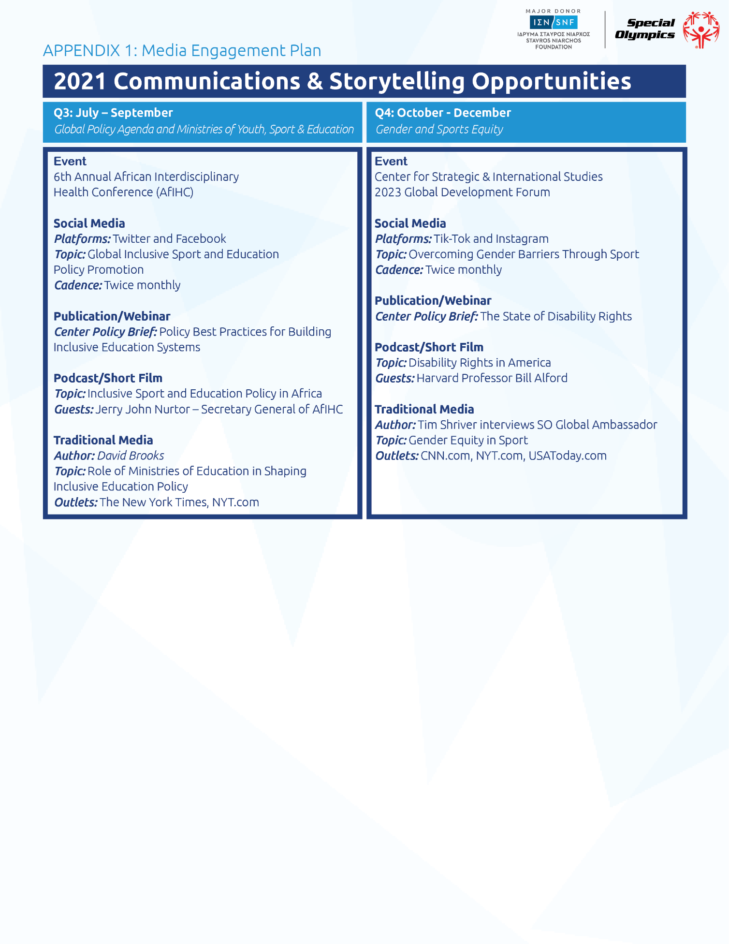

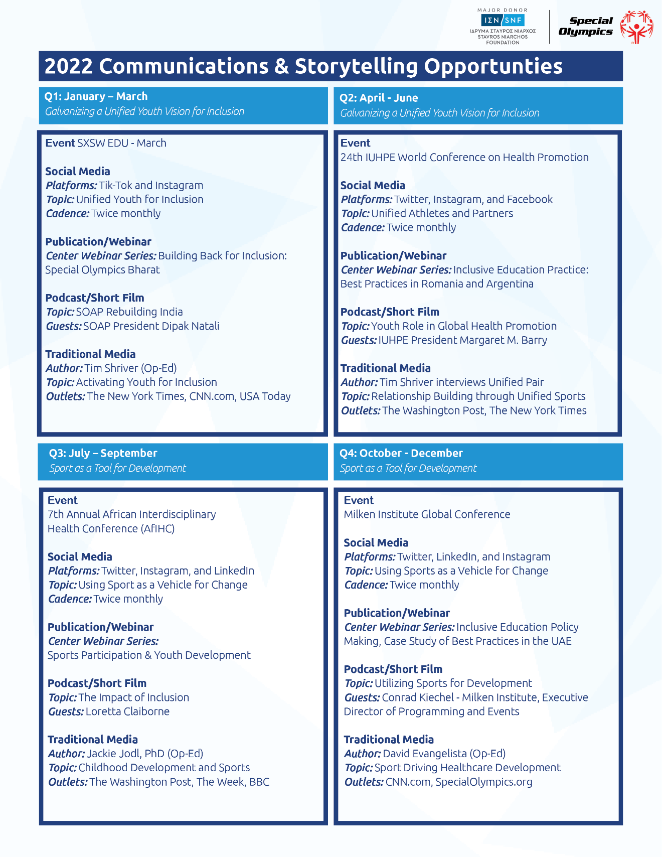

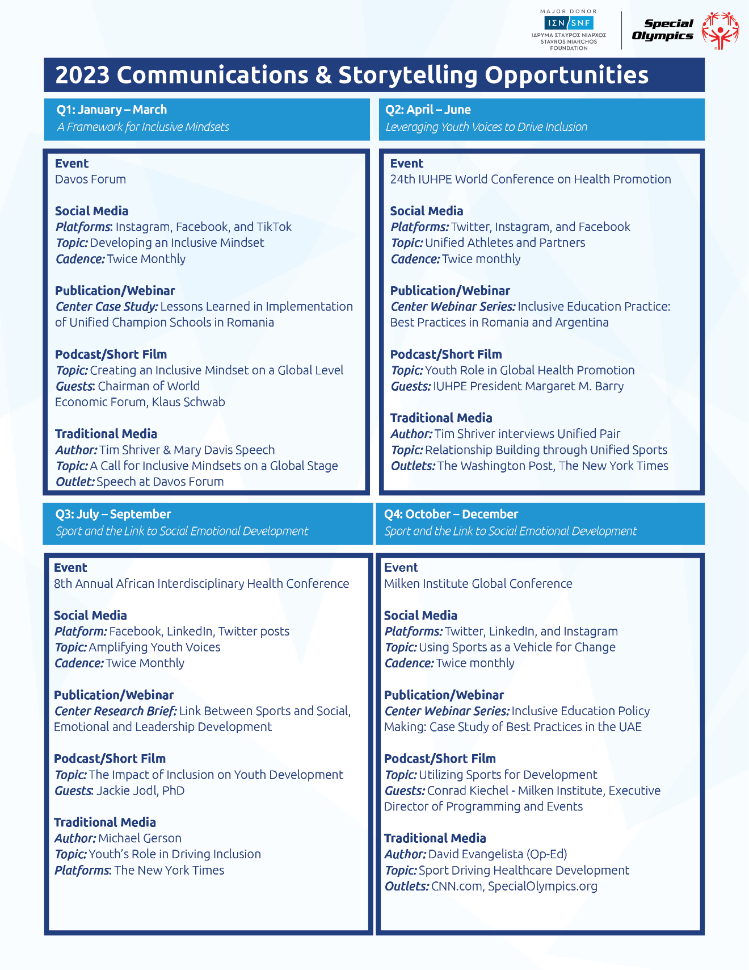

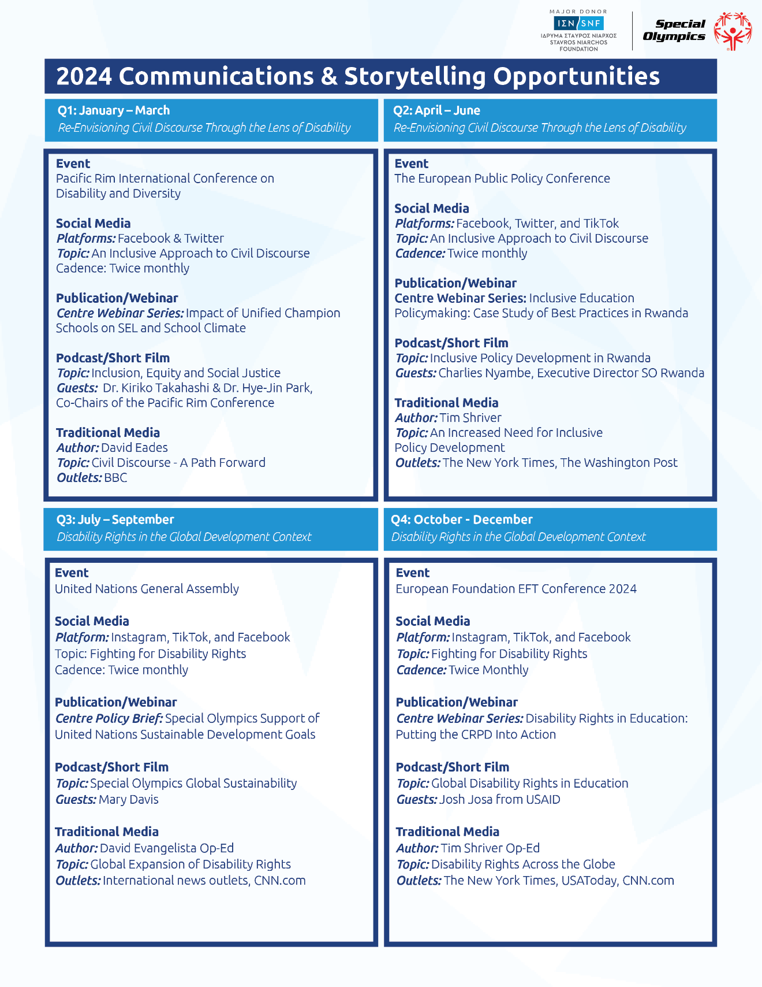

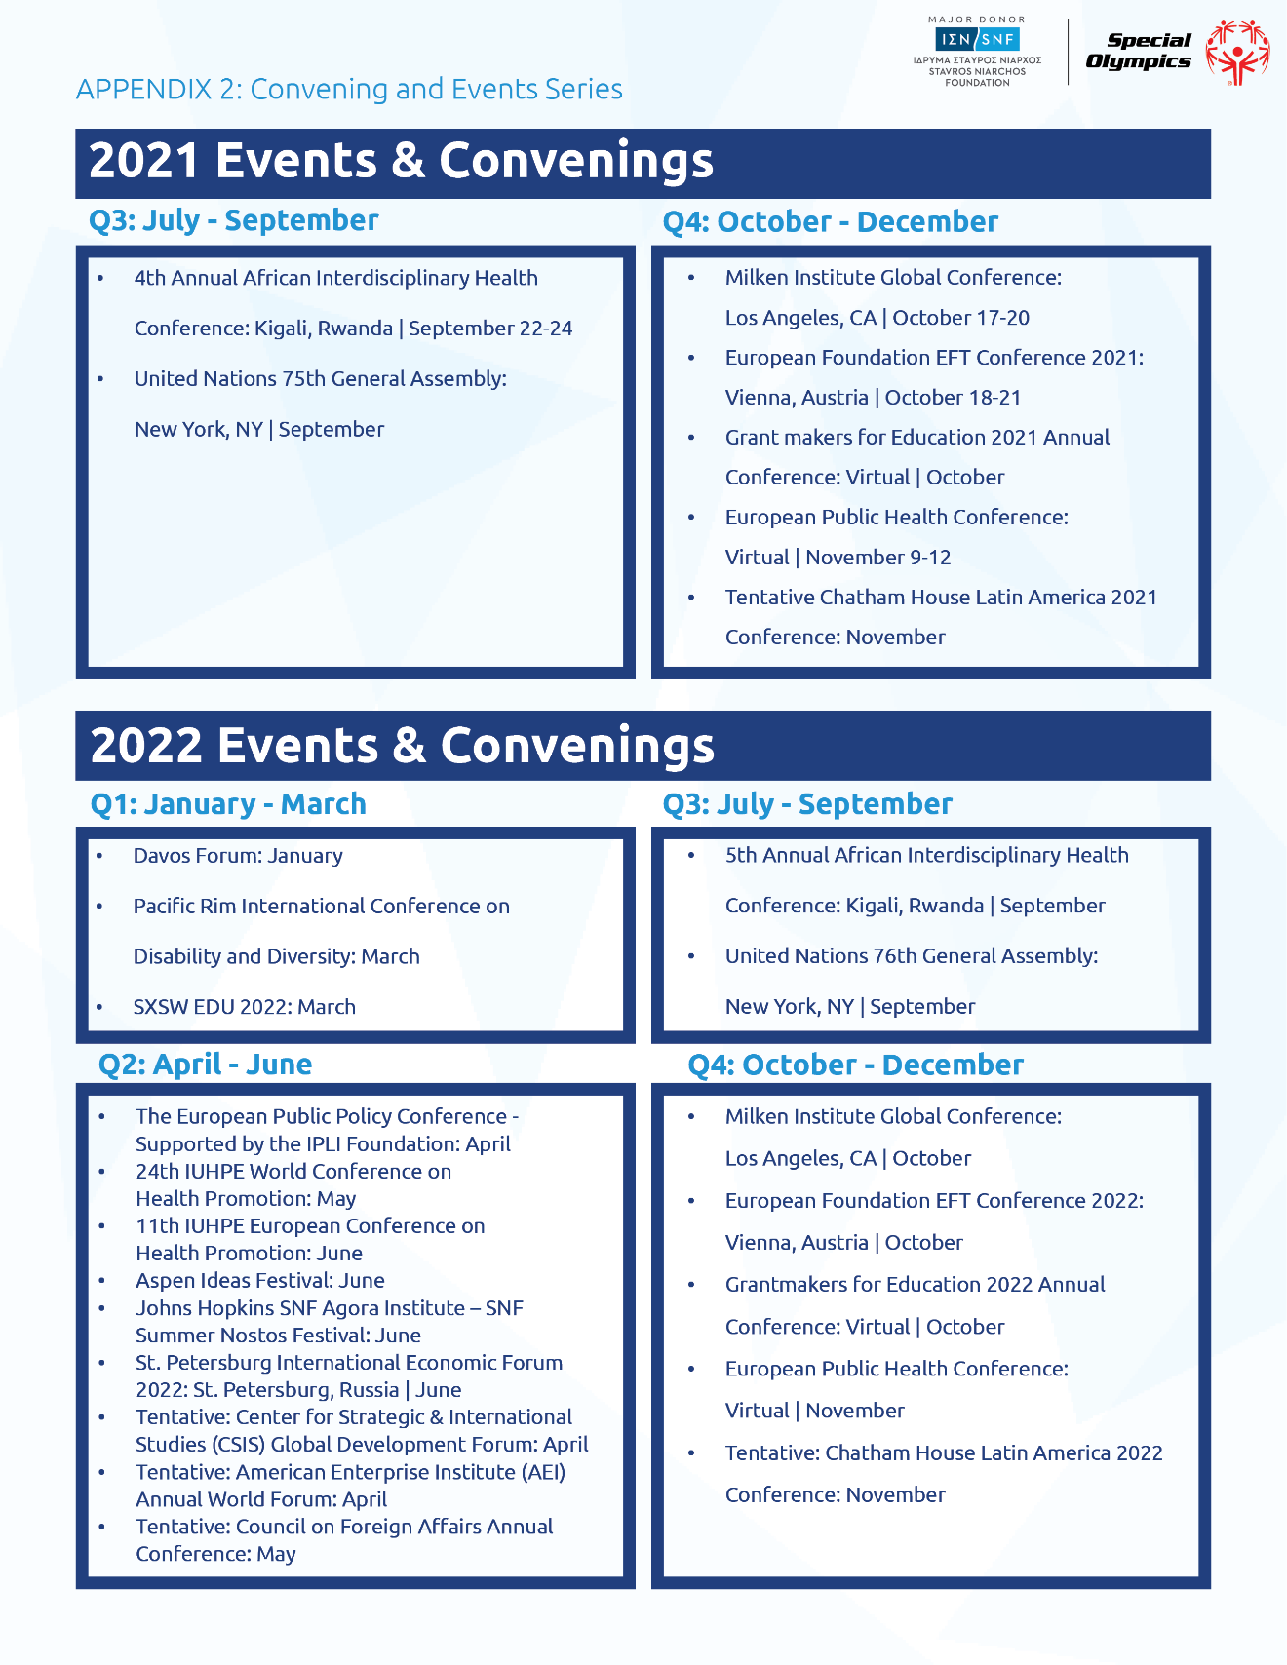

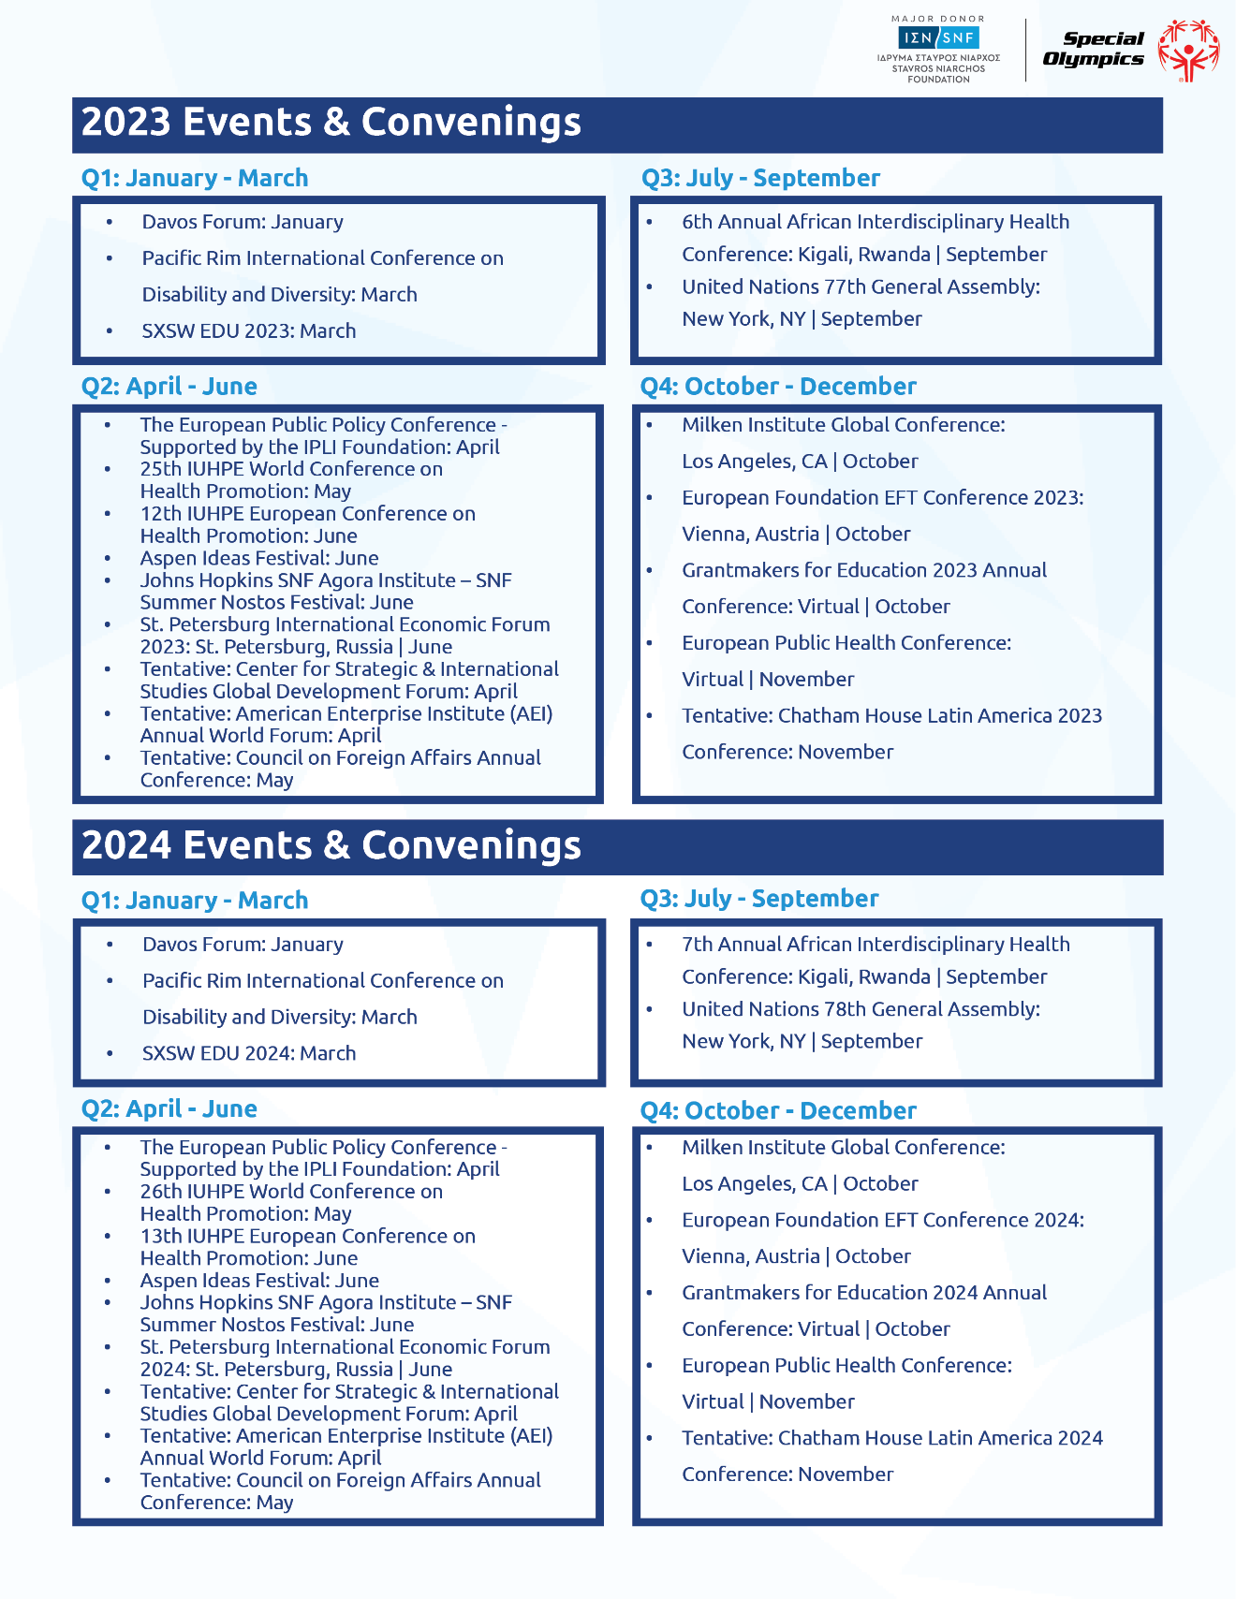

# APPENDIX 2

***

**Special Olympics Brand of Inclusion**

**Concept Statements to Guide the Messaging Strategy**

*Global Thought Leader Campaign*

***Special Olympics Celebrates the Universality of Individual Gifts:***

Everyone has unique gifts. The celebration of individual gifts–-most often understood in the spirit of personal excellence–-is universal. Society, however, tells us what gifts are worthy of celebration. And the determination of that worth is relative, rather than absolute, meaning their value is judged based not on one’s personal best, but another’s best. Special Olympics is unconditionally welcoming of all. We recognize that gifts, and their celebration, are universal. When we are inclusive in our recognition of gifts, all individuals feel valued and celebrated, and we unleash the full potential that lives within each of us. This idea is at the core of the Special Olympics mission–-to enable all people in the “sharing of gifts, skills and friendship with their families, other Special Olympics athletes, and the community.”

***The Goal Is Not to Find the Best. The Goal Is to Be Your Best:***

Special Olympics’ practice of sport represents a different way of competing. Sport at Special Olympics is not a zero-sum game where we label every winner at the expense of a corresponding loser. For Special Olympics, sport and competition is not about finding the best, but rather, supporting and celebrating every person’s best. The goal is to uncover individual strengths and foster individual achievement, where the bravery of attempt is valued over winning. When we enable such a process of self-actualization, we show that yes, winning matters. But it matters because in the pursuit of winning, the unique potential of every athlete is revealed and valued. This value comes to life, in the Special Olympics Athlete Oath; “Let me win, but if I do not win, let me be brave in the attempt.”

***More Powerful Together Than Apart:***

What if every teacher, parent, coach, healthcare worker, law enforcement officer, government leader, community leader, business leader experienced Special Olympics and learned to see the value in individual differences? And the strength in inclusion? How different would our world be?! To marginalize, demean or exclude in response to differences, is a fundamental violation of the spirit of inclusion and does nothing to exalt superiority. If, as opposed to seeing inclusion as a threat, if we embrace diversity as a pathway to greater societal strength, we have the potential to weave together a society that is more powerful together than apart. Thus, the goal of an inclusive society is not about destroying meritocracy but rather supporting communities where we are able to shine as individuals and as a collective. This is a vision of a world that embraces and celebrating difference as a source of strength. This is the world Special Olympics is building.

***The Joyful Uninhibition of the Special Olympics Athlete:***

Special Olympics athletes exude a joyful uninhibition in which they approach every situation with a unique combination of optimism and welcoming domineer. Special Olympics athletes’ pursuit of their sport serves as a remarkable example for the joy that emerges when we value playing together over competing, and relationships over winning. We sometimes see this in professional athletes, too, as competitors help each other and show sportsmanship in the face of loss. And we are moved when a superior performer can be humbled. But when the unpretentiousness is expressed by someone already humbled in life by society’s judgemental eye, we see the pure joy stemming from a pure heart. Special Olympics athletes don’t ask about your politics, gender, nationality, race, or age. They just ask, “Do you want to play?”

***The Great Equalizer:***

Sport has been described as the great equalizer that can build bridges and transcend borders. The goal of competition for Special Olympics is to transcend differences by privileging the encounter, exchange, and relationships of athletes, competitors, and teammates. When athletes participate in Special Olympics, they are no longer seen as someone with a disability but as a teammate or competitor. Through sport, differences fade away. No longer are they seen as an out sider but insider. At its core, the great equalizer for Special Olympics is the underlying value that our athletes place on relationships that emerge when those with and without ID come together on the playing field. Whether it is witnessing the joy that results from the unexpected achievement of a Special Olympic athlete or experiencing the camaraderie that occurs as a member of a unified team, there is something about both the experience and goal of sport and competition that is a great equalizer on and off the field of play. For someone who has been routinely excluded, shunned and dismissed, the relationship becomes the thing that matters most. And so the camaraderie that emerges on the field of play reigns supreme. To be accepted as a teammate by someone who in other circumstances might be the excluder, is sweet indeed.

***Moral Courage:***

So often, when presented with the opportunity to engage in an act of kindness or empathy, being able to take the perspective of the other is important to being able to step out of one’s own comfort. The ultimate manifestation of an inclusive mindset is when an individual is able and willing to risk one’s social capital to include someone who society, the community, one’s peers, have deemed as different, or “other”. When inclusive practices become part of the social fabric, the cost of embracing differences is neutralized. Costs are replaced by incentives to support the new norm. Even better, when norms of inclusion are set by those with the most innate moral courage, in fact celebrated, the stage is set for inclusion to be practiced by all.

1. Social Inclusion of Students with Intellectual Disabilities in Four Countries: Evidence from Special Olympics Global Unified Schools (Report in Preparation), American Institutes for Research, Washington, D.C., 2021.
2. “Special Olympics Announces Global Expansion of Initiative for Inclusion in Education for Young People with and without Intellectual Disabilities: Transformative Gift from His Highness Sheikh Mohammed Bin Zayed Al Nahyan Will Promote Positive Social Change and Foster More Inclusive Societies,” Press Release, Special Olympics International, July 20, 2020; “Congress Strikes Deal on Fiscal Year 2021 Funding, Stimulus Package, Council for Exceptional Children, December 23, 2020.
3. M. Benner, C. Brown, and A. Jeffrey, “Elevating Student Voice in Education,” The Center for American Progress, August 14, 2019; V.T. Lac and K.C. Mansfield, “What do Students have to do with Educational Leadership? Making a Case for Centering Student Voice,” *Journal of Research on Leadership Education*, 2018, 13(1):38-58. Doi:10.1177/1942775117743748; D. Mitra, S. Serriere, and D. Stoicovy, “The Role of Leaders in Enabling Student Voice,” *Management in Education* 26(3), 2012: 104-112. V. Johnson and A. West, *Children’s Participation in Global Contexts: Going Beyond Voice*, Milton: Routledge, 2018, https://public.ebookcentral.proquest.com/choice/publicfullrecord.aspx?p=5327098.
4. G. C. Savage, “Think Tanks, Education and Elite Policy Actors,” Australian Educational Researcher 43, 35-53 (2016); T. Medvetz, “Murkey Power: Think Tanks’ as Boundary Organizations,” 2012; D. Courpasson, D. Golsorkhi, and J.J. Sallez, (Ed.) “Rethinking Power in Organizations, Institutions, and Markets,” Research in the Sociology of Organizations, Vol. 34, Emerald Group Publishing Limited, Bingley, 113-133.
5. G. Weimann, The Influentials: *People Who Influence People*, Albany: State University of New York Press, 1994; A. Rich, *Think Tanks, Public Policy and the Politics of Expertise*, Cambridge: Cambridge University Press, 2004.
6. G. C. Savage, “Think Tanks, Education and Elite Policy Actors,” Australian Educational Researcher 43, 35–53 (2016); T. Medvetz, "Murky Power: Think Tanks’ as Boundary Organizations," 2012; D. Courpasson, D. Golsorkhi, and J. J. Sallaz, (Ed.) “Rethinking Power in Organizations, Institutions, and Markets,” *Research in the Sociology of Organizations*, Vol. 34, Emerald Group Publishing Limited, Bingley, 113-133.
7. G. Weimann, *The Influentials: People Who Influence People*, Albany: State University of New York Press, 1994; A. Rich, *Think Tanks, Public Policy and the Politics of Expertise*, Cambridge: Cambridge University Press, 2004.